Spellchecker for VFP apps.
This simple class is an extract from a class I once wrote with the purpose to include the word spellchecker in my apps.
Typically editboxes, containing memofield contents, are the place to use this class, however, nothing would stop you from using it elsewhere.

How to use it.
Instanciate the class with:
oSpell = CreateObject(“Spellcheck.spellcheck”)
OR
oSpell = NewObject(“spellcheck”,”spellcheck”)

In the doubleclick of the control where you want to use it place some code like:
oSpell.controldblclick( thisform, this)

The spellchecker form has some code in the dblclick of the memofield.
*****
LOCAL loSpell AS spellcheck OF "spellcheck.vcx"

IF VARTYPE( loSpell) <> "O"
loSpell = NEWOBJECT("spellcheck","spellcheck")
ENDIF

loSpell.controldblclick( THISFORM, THIS)
*****
When running the form it looks like this:

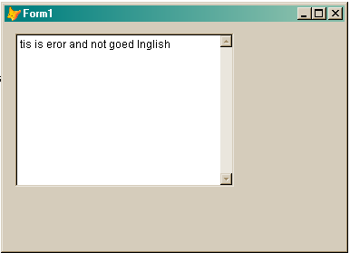

There are “some” errors in the text above…
Now we doubleclick the editbox.
First a check is done whether Word is installed, if that is not the case you get a message saying that word cannot be started.

In any other case you get the word dialog for spellingcorrections.
After you’re done the complete text in the editcontrol is overwritten by the corrected text.
If the control has a controlsource that is automatically filled with the new value as well.

The form will then look like this:
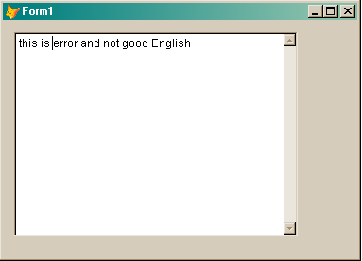

Have fun… may the fox be with you.

Boudewijn Lutgerink.

